Activating your NetOptimizer Installation

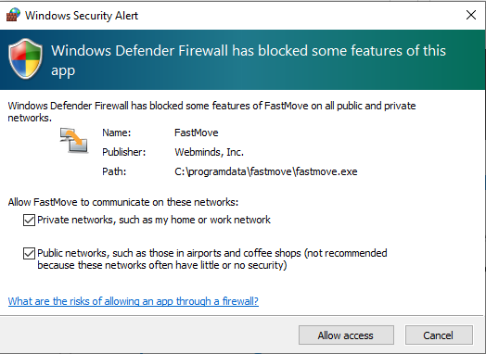

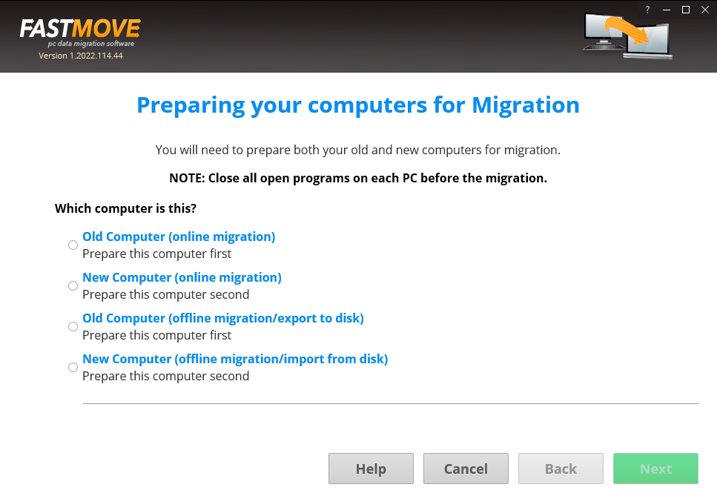

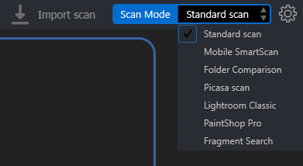

Performing a Standard Scan

Performing a Mobile SmartScan

Performing a Folder Comparison

Performing a Picassa Scan

Performing a Lightroom Classis Scan

Performing a PaintShop Pro Scan

Performing a Fragment Search